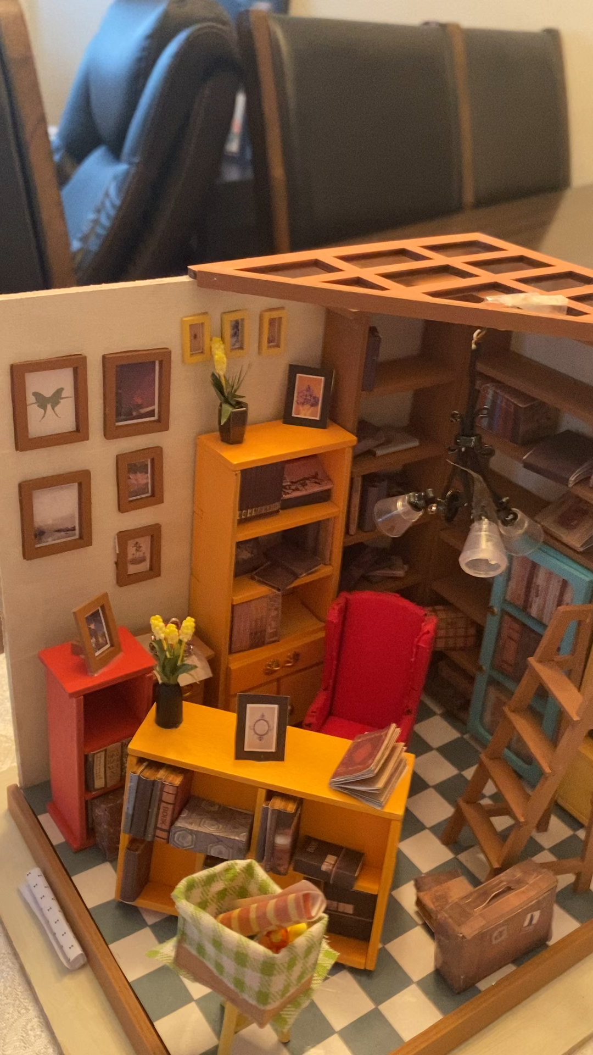

From the video about doll houses or miniatures. can you fill up this self assessment, and also do a paragraph I give you the instruction bellow will be in MLA format. And also help me if the video not good I can fix it later.

One paragraph in proper MLA format explaining your choice of mini documentary (why did you choose to do your documentary on this topic?). *Remember: if you used any external sources, please list them in a Works Cited*

In the space to the left, complete the self-assessment reflecting on your Unit 3 Mini Documentary.
Include this assessment when you submit your documentary.
Self Assessment | Evaluation Criteria | Teacher Assessment
Knowledge and Understanding
- Demonstrates understanding of their presented topic.
- Information presented is accurate and up to date.

 | Thinking and Inquiry  - Demonstrates creative thinking skills when choosing what information to incorporate and present with technological elements. | .
Communication
- Subject is introduced, viewers’
attention is captured and held,
viewers can easily follow, material is appropriate and meets the goals of the assignment.
- Explanation paragraph clearly explains student’s reasoning for choosing both topic and presentation choices.

Application
- Effectively uses medium to communicate ideas and information.
- Mini documentary is clear both in sound and picture.
- Student credits and cites any used sources appropriately for all information and media used.
- Proper spelling and grammar are used in Explanation Paragraph
- MLA document format used.

Comments:

